

Matthew Perry
Lauren Graham
Ben Foster
Ginnifer Goodwin
Hilary Swank

in

BIRDS OF AMERICA

Directed by Craig Lucas

PRESS NOTES

JOURNALISTS PLEASE NOTE: The filmmakers kindly request that you avoid revealing the film’s ending in your coverage.

SALES CONTACT: PRESS CONTACT:
Dina Kuperstock Jeremy Walker + Associates
Creative Artists Agency Dan Goldberg
2000 Avenue of the Stars 160 West 71st St,. No. 2A
Los Angeles, California 90067 New York, NY 10023
424-288-2000 212-595-6161
dkuperstock@caa.com dan@jeremywalker.com

CAST

Morrie MATTHEW PERRY
Betty LAUREN GRAHAM
Jay BEN FOSTER
Ida GINNIFER GOODWIN
Laura HILARY SWANK
Paul GARY WILMES
Gillian ZOE KRAVITZ

FILMMAKERS

Directed by CRAIG LUCAS
Written by ELYSE FRIEDMAN
Producer DANIELA TAPLIN LUNDBERG
Producer JANA EDELBAUM
Producer GALT NIEDERHOFFER
Producer CELINE RATTRAY
Executive Producer JOHN ALLEN
Executive Producer SCOTT HANSON
Executive Producer PAMELA HIRSCH
Executive Producer ED HART
Executive Producer BRUCE LUNSFORD
Executive Producer ERIC GOLDMAN
Co-Producer ELYSE FRIEDMAN
Co-Producer HOLLISE GERSH
Co-Producer ED GERSH
Co-Producer MARILYN HAFT
Co-Executive Producer CHRIS DAVEY
Co-Executive Producer RACHEL COHEN
Director of Photography YARON ORBACH
Editor ERIC KISSACK
Production Designer JOHN NYOMARKAY
Original Music AHRIN MISHAN
Costume Designer HEIDI BIVENS
Sound Mixer JOSH ANDERSON
Key Makeup Artist PERSEFONE KARAKOSTA
Key Hair Artist THEODORA KATSOULOGIANNAKIS

SYNOPSIS

Some of our best artists’ most resonant work has observed that Americans’ hunger to secure, maintain and defend their status in the mythic middle class can breed all kinds of deep and conflicting feelings among siblings: think Cheever and Franzen, Solondz and Ball and now Craig Lucas.

The title of his new film refers to the iconic Audubon series of engravings coveted by a certain stripe of the American bourgeoisie, an original edition of which the deceased father of the family in question has left, along with a substantial mortgage, to his offspring, led by Morrie (Matthew Perry). The oldest, Morrie ended up raising his younger brother Jay (Ben Foster) and kid sister Ida (Ginnifer Goodwin) in the same house in which he now lives with his wife, Betty (Lauren Graham). Jay’s life is a dangerous mess and when he and Ida come to live with Morrie and Betty Jay’s antics highlight the social tightrope they are walking with the picture-perfect couple (Gary Wilmes and Hilary Swank) next door.
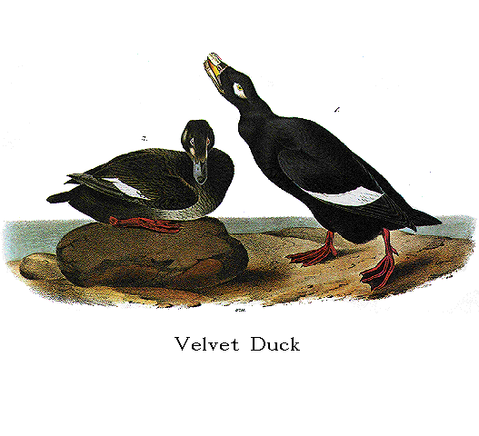

TWO BIRDS IN A NEST

If you spend just a few minutes with Lauren Graham and Matthew Perry you will learn very quickly that they are fast friends and adore one another’s company.

Imagine the Warner Bros. lot in Burbank, where for over a decade Perry shot the TV show Friends and also where Graham spent seven years shooting Gilmore Girls. Now imagine, after he moved on to the acclaimed Aaron Sorkin drama Studio 60 on the Sunset Strip, which was shot not on the Sunset Strip but again on the Warner Bros. lot, that Perry suggested a cameo for Graham on an episode of his new show in which she would play herself, a TV actress on a hit show just dropping by the other show’s set.

All that happened on TV because it also happened in ‘real life.’

You learn this on a rainy Saturday in Beverly Hills, over lunch with Graham and Perry at a lounge in a famous hotel that is near the Sunset strip, a restaurant at which stars who live nearby routinely keep business appointments such as this. Indeed, it was Perry who suggested you meet here, which on this particular afternoon also hosts Reese Witherspoon, Vince Vaughan, ‘Law & Order’ creator Dick Wolf and, incongruously, Stephen Dorff in a tuxedo (Dorff, you observe later, is participating in a family wedding).

Graham arrives a few minutes before Perry and starts to recount how she became involved in BIRDS OF AMERICA.

“I was in New York and full of conflicted feelings about Gilmore Girls coming to an end,” she says. “We’d just shot the final episode and I still hadn’t even become used to not having to be up at six every morning. So I was at dinner in New York when my phone rang with the news that Craig Lucas wanted to meet me the next day. The meeting went great and we started shooting two weeks later.

“BIRDS OF AMERICA was very different from what I’d been doing,” Graham continues. “Gilmore Girls was very ‘rat-a-tat-tat,’ a high energy show with lots of language. We’d shoot nine, ten eleven pages a day, but we always had time – time to rehearse, talk, prepare. On this movie, we worked insanely quickly: I remember hearing ‘rolling!’ the second I’d set foot on set. Now, I’m not someone who needs a lot of rehearsal but this was like ‘hey, guys, tell me where we’re going!’ I’d never been in a position where I actually wanted to do more takes; if you love a scene, you don’t want to let it go. But two, three takes later and it’s like ‘we’re moving on!’”

The talk turns to Graham’s great speech in BIRDS OF AMERICA, when her character responds to a sarcastic question from her husband’s brother (Ben Foster) about whether she loves her washer-dryer.

“One thing I’ve noticed, now that I’m out in the world and reading scripts, is that these kinds of secondary female parts tend to further the action without commenting on it. With that speech I thought it was really beautiful the way this woman gets to explain to the audience how a new washer dryer made everything whole and clean and fresh in a house – and possibly a marriage – that is otherwise old and breaking down.”

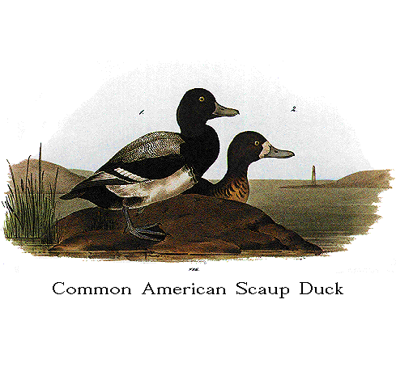
Graham explains that her friend Matthew Perry was involved with BIRDS OF AMERICA long before she and that making the movie was “a very different process for him. It must have been hard for him. Craig comes from the theatre, and -- ”

Perry arrives. He is friendly and funny and self-deprecating and a bit unkempt. While Graham has shown up in a skirt and jacket, Perry wears jeans and a polo shirt over what looks like the top of a set of long underwear. He admits he looks like he just got out of bed because, well, he did: he is shooting a “major motion picture” right now that had him working until three this morning.

Graham teases Perry: she is usually the late one, and he is always on time. “I was just saying how Craig comes from the theatre and how BIRDS was a different process for you.”

“I ended up loving the way Craig works,” Perry says, “but I had to get used to it.”

Graham and Perry explain that Lucas didn’t allow the actors to talk to each other about their characters.

“Usually you sit around with the cast and say, ‘I’ll do this, why don’t you do that thing you do.’ You work it out beforehand. That’s the way we did it for years on Friends.

“We could talk with him,” Perry says of Lucas, “just not each other.”

“You have no idea where the scene is going to go,” Graham interjects. “Nothing was familiar, and that’s a very precarious place to be as an actor.”

“He wanted me to drop every single shred of charm I usually bring to a role” – here Perry grins – “and as you can tell, I’m a pretty charming guy.”

Graham, again: “Anything you think of when you think of Matthew Perry –his sarcasm, his natural sense of irony – Craig would say ‘don’t do that.’”

“Ultimately it was very freeing,” Perry says. “I had to throw away all of my crutches, all of the things I normally rely on as an actor.”

You rewind BIRDS OF AMERICA in your mind’s eye. You recall Perry’s character, Morrie, as a man who has worried his whole life: about his brother and sister, whom he raised; about paying the mortgage, which he inherited when his father died when they were young; about making tenure, and about plans for children of his own, which he and his wife have put on hold until their future is more certain.

“To use a bad baseball analogy,” Perry continues, “I’ve always been the pitcher in movies before this, the guy who starts all the action. For this one, I am more like the catcher – the character is completely beaten down by everything and everyone around him.”

Like Graham, Perry began work on BIRDS OF AMERICA shortly after his series ended, and he was exhausted. “Studio 60 was just really hard work,” he says. “Lots and lots of dialog, long hours, and on top of it not enough people were watching.” In fact, there was a moment Perry considered letting go of the feature, but the quality of the script brought him back.
“It’s so rare you actually get to the end of a script,” he says. “This one was so emotional and I so connected with these people, I couldn’t bear the idea of it going to someone else. So I think I took the fact that I was tired and frustrated by Craig’s restrictions and put them back into Morrie.”

BIRDS OF AMERICA was shot in idyllic Norwalk, Connecticut over the course of five weeks, most of it in one main location. Before production began, Lucas staged a table-reading with the cast, only he instructed each actor to read a part that was not their own.

“He wanted us to feel no pressure to act, but rather for us to listen to the language,” Perry says.

It was the first time Perry and Graham had worked with Foster and Goodwin.

“I had met Ginnifer once,” Graham says, “but not Ben. During production they stayed in Norwalk, and I commuted in from my place in New York, which felt right since my character is related to them by marriage and not blood. It helped me to be more of an outsider. But I think both of them in their own way sort of fell in love with Matthew.”

Adds Perry, “What I immediately learned from meeting them for the first time is that they are very serious actors, and I remember thinking ‘I guess we’ll really have to pay attention.’ They were really focused on the characters, their motivations, how we would relate to each other. I’ve done whole movies when the cast never talked about that stuff once. They are both really dedicated and really fun to work with. Their careers are about to take off.”

One of the very first scenes Lucas shot had Morrie discovering that his brother is homeless and living in the woods. “It was a total fish out of water experience for me,” Perry recalls. “We were in this park behind a baseball field, surrounded by trees and bugs and I’m in this suit and Ben’s acting like gangbusters. I felt just as unsure and off-balance as the character.”

He remembers, when he and Goodwin shot the scene in which Ida suggests Morrie ought to try having sex with his wife, that Craig was ‘all about keeping Ginnifer in motion while I had to stay absolutely still: if I was leaning on my left leg, Craig would tell me to stop.”

Both Perry and Graham observe that it was a supporting actor with a much smaller role – Hilary Swank – that may have shaped their performances the most.

“This extremely anxious couple is so focused on the future,” Graham says. “Their mentality is, ‘if we can just get through the next few days, everything will be OK. When Hilary came to shoot her scenes, we were all of course aware that her company helped get this movie made, and we all wanted her to like us! We wanted this huge movie star to think everything was going really well! And those feelings really would have clicked for Morrie and Betty, who share this uniquely American desire for your neighbor’s approval, the desire to fit in.”

ABOUT THE CAST

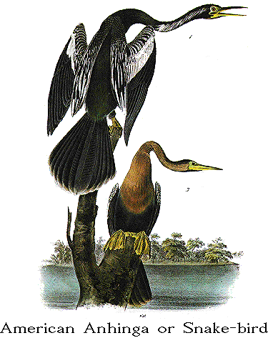
MATTHEW PERRY - MORRIE

Although Matthew Perry is best known for his Emmy-nominated role as 'Chandler Bing' on Friends, his recent projects have brought him critical acclaim for his dramatic performances.

Currently, Perry is in production on the New Line film SEVENTEEN directed by Burr Steers (IGBY GOES DOWN) and co-starring Zac Efron and Michelle Trachtenberg.

Perry has received Emmy, Golden Globe and SAG Award nominations for his starring role in TNT’s “The Ron Clark Story” which aired on August 13, 2006. Based on a true story, Perry stars as Ron Clark, a teacher who leaves his hometown in North Carolina to teach in one of New York City’s worst schools. Clark’s efforts and his students’ successes earned him Disney’s “Teacher of the Year” in 2002. “The Ron Clark Story” was TNT’s highest-rated original movie since 2004’s The Librarian.

Perry was most recently seen starring in NUMB, an independent film directed by Harris Goldberg. The film screened at the 2007 Tribeca Film Festival and also stars Mary Steenburgen, Kevin Pollak and Lynn Collins. In 2006, Perry returned to series television to star in Aaron Sorkin’s NBC drama, “Studio 60 on the Sunset Strip” in a role that was written for him.

In July 2005, Perry took his talents to the athletic arena as he hosted the 2005 ESPY Awards. The broadcast earned the highest rating in the 12-year history of the ESPYs.

In 2004, Perry starred alongside Bruce Willis in the Warner Bros. film THE WHOLE TEN YARDS, the sequel to the box office hit THE WHOLE NINE YEARDS in which he also appeared. Perry received critical acclaim once again for his undeniably unique talent for physical comedy. He also received an Emmy nomination in the category of “Outstanding Guest Actor in a Drama Series” for his role as ‘Joe Quincy’ on “The West Wing.”

That same year Perry made his directorial debut with an episode of the off-beat hit comedy “Scrubs.” Perry also guest-starred in the episode playing the role of a man willing to donate a kidney to his ailing father until complications arise. The role of the ailing father was played by John Perry, Matthew real-life father.

Perry’s feature film debut was in 1988 in A NIGHT IN THE LIFE OF JIMMY REARDON starring River Phoenix. In 1999, Perry starred with Neve Campbell, Dylan McDermott and Oliver Platt in THREE TO TANGO. His other feature film credits include ALMOST HEROES with the late Chris Farley and Eugene Levy; FOOLS RUSH IN with Salma Hayek; and SERVING SARA with Elizabeth Hurley.

Perry realized one of his personal challenges when he made his stage debut in London’s West End in the spring of 2003 in David Mamet’s “Sexual Perversity in Chicago.” He co-starred alongside Minnie Driver, Hank Azaria and Kelly Reilley. The play broke the record for the largest box-office advance for a West End show.

Born in Williamstown, Massachusetts, Perry was raised in Ottawa, Canada. At age 15, he moved to Los Angeles to live with his father, actor John Bennett Perry. In addition to performing in several high school stage productions, he was an avid tennis player. He ranked number seventeen nationally in the junior singles category and number three in the doubles competition.

Matthew continues to support and host the annual gala for the Lili Claire Foundation which raises funds for those born with Williams Syndrome and other neurogenetic birth defects.


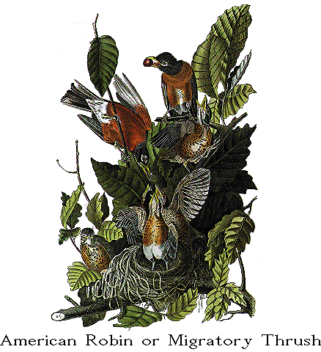

LAUREN GRAHAM – BETTY
Lauren Graham recently completed production on FLASH OF GENIUS with Greg Kinnear for Universal and Spyglass Entertainment.

Graham garnered critical acclaim for her performance as Lorelai Gilmore on “Gilmore Girls;” a series on which she also served as producer in its final season.

For her work on the show Graham has been nominated for a Golden Globe Award for “Best Actress in a Drama Series,” two Screen Actors Guild Awards for “Outstanding Female Actor in a Drama Series” and two Television Critics Association Awards for “Individual Achievement in Drama and Comedy.” Additionally, she has earned two Teen Choice Awards for “Choice Parental Unit,” a “Best Actress” nod from Viewers for Quality Television and was recently honored by Planned Parenthood as a “Champion of Choice” for her work with family issues on and off-screen. In addition to “Gilmore Girls,” Graham’s list of television credits includes parts in “NewsRadio,” “Law & Order,” “Seinfeld” and “3rd Rock from the Sun.”

Graham’s additional feature film credits include Universal’s blockbuster comedy EVAN ALMIGHTY, alongside Steve Carell; BECAUSE I SAID SO, opposite Diane Keaton and Mandy Moore; BAD SANTA, with Billy Bob Thornton; THE PACIFIER, opposite Vin Diesel; “THE AMATEURS, opposite Jeff Bridges and Tim Blake Nelson; the thriller NIGHTWATCH, starring Patricia Arquette and Ewan McGregor, and ONE TRUE THING. In 2002, Graham made a notable appearance on stage at The Williamstown Theatre Festival starring in “Once in a Lifetime,” the 1929 comedy about the advent of motion pictures.
Growing up an avid equestrian in Northern Virginia, she attended Barnard College in New York, where she majored in English. She then earned an M.F.A. in Acting from Southern Methodist University. Graham currently has residences in both New York and Los Angeles.


BEN FOSTER – JAY

An award winning actor who has established himself as one of the most versatile of his generation, Ben Foster continues to add to a collection of diverse roles in 2007.

Currently Foster can be seen in James Mangolds' 3:10 TO YUMA opposite Russell Crowe. His portrayal of outlaw Charlie Prince, a cold blooded killer with a a pair of deadly six guns and a love for using them, has earned him rave reviews. He's been called "gifted" by David Denby (The New Yorker) and Kenneth Turan calls his performance "one of 3:10 TO YUMA’s signature elements."

Foster was last seen in Nick Cassavetes' ALPHA DOG opposite Sharon Stone and Emile Hirsch for which he was honored with Movieline's Hollywood Life Breakthrough Performance Award. In the film, Foster plays Jake Mazursky, a crystal meth addicted skin head looking to exact revenge for the kidnapping of his brother. The film made its debut at the 2006 Sundance Film Festival.

Foster's credits also include the blockbuster film X MEN 3: THE LAST STAND. Directed by Brett Ratner, Foster portrayed Warren Worthington III/Angel, a highly anticipated character in 20th Century Fox's successful franchise. The cast included Patrick Stewart, Ian McKellan, Hugh Jackman, Halle Berry and Famke Janssen. X-MEN 3 was the highest grossing film of the franchise. Additional credits: 30 DAYS OF NIGHT opposite Josh Hartnett, HOSTAGE opposite Bruce Willis, THE PUNISHER opposite Thomas Jane, NORTHFORK opposite James Woods, Anthony Edwards and Daryl Hannah and Barry Levinson's LIBERTY HEIGHTS which marked his film debut.

On television, Foster shared the SAG Award for Best Ensemble Cast for his work in the 2003 season of HBO's critically acclaimed drama "Six Feet Under" in which he portrayed Russell Corwin for three seasons. He appeared in several episodes of the cult hit "Freaks and Geeks" as the mentally handicapped student Eli. His lead performance in Showtime's "Bang Bang You're Dead" garnered Foster a Daytime Emmy. Ben lives in Los Angeles with his brother, actor Jon Foster.

GINNIFER GOODWIN - IDA


Hailing from Memphis, Tennessee, Ginnifer Goodwin has quickly found a home in Hollywood. With effusive talent, she shined in the Oscar-nominated biopic WALK THE LINE, as Johnny Cash’s first wife, opposite Joaquin Phoenix and Reese Witherspoon. Currently, she can be seen in HBO’s critically acclaimed dramatic series BIG LOVE, now in its third season, produced by Tom Hanks’ Playtone Productions. She stars as the youngest and third of three wives in a modern-day polygamist family, with Bill Paxton as the patriarch, Jeanne Tripplehorn and Chloe Sevigny – wives one and two, respectively.

Goodwin will next be seen in the independent project DAY ZERO with Chris Klein and Elijah Woods opening in January 2008. She is currently filming the ensemble comedy HE’S JUST NOT THAT INTO YOU for New Line based on the best-selling book by Greg Behrendt.

Her breakthrough role was in her first feature film ever - Mike Newell’s MONA LISA SMILE starring alongside Julia Roberts, Marcia Gay Harden and Kirsten Dunst. This freshman performance garnered industry buzz and critical interest and she was considered a standout among an experienced ensemble. Soon after, she starred in Robert Luketic’s romantic comedy, WIN A DATE WITH TAD HAMILTON, opposite Kate Bosworth, Topher Grace and Josh Duhamel. She has also lent her acting talents to a small cameo in Jon Kasdan’s IN THE LAND OF WOMEN.

Goodwin is classically trained in English theatre. She studied at Stratford-upon-Avon’s Shakespeare Institute in conjunction with the Royal Shakespeare Company. She also earned an “Acting Shakespeare Certificate” at London’s Royal Academy of Dramatic Art, where she played Joan of Arc, Ophelia and Jessica in “The Merchant of Venice.” Then a few years later, she attended the London Academy of Music and Dramatic Arts.

At Boston University, Goodwin performed at the Huntington Theatre in productions such as “Dead End” with Broadway director Nicholas Martin. Subsequently, Goodwin was awarded with the Excellence in Acting: Professional Promise Award by The Bette Davis Foundation and graduated with honors. After her college graduation, she quickly got a small role on “Law and Order.” Then, at the top of its second season, NBC’s “Ed” welcomed Goodwin as a regular. She also starred in Comedy Central’s collaboration with Tribeca Films: “Porn N Chicken”. Goodwin currently resides in Los Angeles.

HILARY SWANK – LAURA

HILARY SWANK is a two-time Academy Award winner in the category of Best Actress. She won her first Oscar for the role of Brandon Teena in the 1999 drama BOYS DON’T CRY. She also won a Golden Globe Award and Critics’ Choice Award, as well as New York Film Critics, Los Angeles Film Critics, Chicago Film Critics, and National Society of Film Critics Awards in the same category. Additionally, the National Board of Review recognized Swank’s work with the Breakthrough Performance of the Year Award and she earned BAFTA and Screen Actors Guild (SAG) Award nominations.

In 2005, Swank won her second Academy Award for her starring role in Clint Eastwood’s Oscar-winning Best Picture MILLION DOLLAR BABY opposite Eastwood and Morgan Freeman. In addition, she won her second Golden Globe Award and a SAG Award, as well as the National Society of Film Critics and Critics’ Choice Awards for Best Actress. That same year, she earned Golden Globe Award and SAG Award nominations for her portrayal of suffragette Alice Paul in the HBO movie IRON JAWED ANGELS.

Swank recently collaborated with director Richard LaGravenese when she starred in the true-life drama FREEDOM WRITERS, playing inspirational schoolteacher Erin Gruwell. Last year, she co-starred with Scarlett Johansson and Josh Hartnett in Brian De Palma’s real-life crime drama THE BLACK DAHLIA. Swank’s other film credits include Charles Shyer’s THE AFFAIR OF THE NECKLACE opposite Adrien Brody; Sam Raimi’s THE GIFT with Cate Blanchett and Keanu Reeves; Christopher Nolan’s INSOMNIA opposite Al Pacino and Robin Williams; and Stephen Hopkins’ horror thriller THE REAPING.

Swank is next set to star as Amelia Earhart in AMELIA, the biopic about the legendary aviatrix, to be directed by Phillip Noyce.

ZOE KRAVITZ - GILLIAN

Zoe Isabella Kravitz was born on December 1, 1988 in New York City. As the daughter of musician Lenny Kravitz and actress Lisa Bonet a love and admiration for the arts has always been amongst her main priorities and passions. Last year Zoe appeared t in two films:
NO RESERVATIONS, directed by Scott Hicks, in which she appeared alongside Catherine Zeta Jones and Aaron Eckhart and the action thriller film THE BRAVE ONE, directed by Neil Jordan and starring Jodie Foster and Terrance Howard. Kravitz completed work on both pictures during her final year at high school. Zoe resides in New York City and was recently accepted to SUNY Purchase’s Performing Arts program.

GARY WILMES - PAUL

Gary Wilmes won an Obie Award in 2006 for his performance in "Red Light Winter," a three-character drama produced by Scott Rudin. "Red Light Winter" premiered at Steppenwolf's Garage Theatre and moved to New York after an extended, sold-out run in Chicago. Wilmes' New York acting credits include "Brace Up!" with the Wooster Group; "Paradise Hotel" with Richard Foreman: The Obie award winning "House" with Richard Maxwell; "More Lies About Jerzy" at the Vineyard Theatre; and "Shoppers Carried by Escalators into the Flames" written by National Book Award winner Denis Johnson. Wilmes has been a regular on "Late Night with Conan O'Brien" and a guest star on "Numb3rs." His film credits include Hal Hartley's THE GIRL FROM MONDAY; Adam Rapp's BLACKBIRD; and the Michael Winterbottom films GENEVA and A MIGHTY HEART with Angelina Jolie.

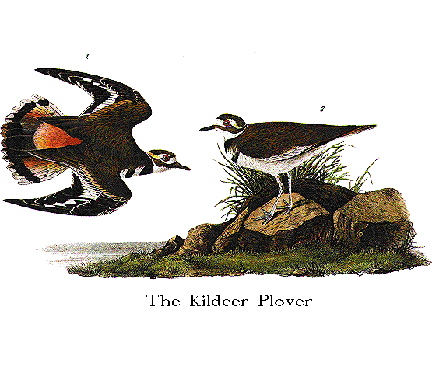
ABOUT THE FILMMAKERS

CRAIG LUCAS – DIRECTOR

Craig Lucas was last at Sundance in 2005 with THE DYING GAUL, which he wrote and directed. He also wrote the screenplay for LONGTIME COMPANION, which won the Audience Award at Sundance in 1990. His other screenplays include BLUE WINDOW, PRELUDE TO A KISS, RECKLESS and THE SECRET LIVES OF DENTISTS (New York Film Critics Award for Best Screenplay of 2003). Lucas won an Obie for his direction of Harry Kondoleon's play "Saved or Destroyed" and was a finalist for the Pulitzer Prize for the play of "Prelude to a Kiss." He wrote the book for the musical "The Light in the Piazza" which won 6 Tony awards in 2005 which somebody should make into a movie. He is currently adapting Brecht's "Galileo" for director Daniel Sullivan and hoping to direct his screenplay SMALL TRAGEDY before the arrival of the four horsemen of the apocalypse.


ELYSE FRIEDMAN – WRITER
Elyse Friedman’s most recent book is “Long Story Short, A Novella & Stories.” She has written two novels: “Waking Beauty” and “Then Again” (shortlisted for the Trillium Book Award) and a book of poetry: “Know Your Monkey” (a ForeWord Magazine ‘Book of The Year’). In 2006, Elyse received two National Magazine Award nominations for short fiction. Her story, “The Soother” won the Gold Award.

Elyse is a graduate of the Writers’ Resident Program at the Canadian Film Centre. She lives in Toronto, where she is currently raising her son, writing a new novel and working on several screenplays.


ERIC KISSACK – EDITOR

Eric Kissack got his start editing funny television shows like "The Daily Show," "The Al Franken Show," "Stella" and the "Whitest Kids U Know". His first feature film, THE TEN, directed by David Wain, premiered at Sundance in 2007. He is currently editing David Wain's as-yet-untitled new film for Universal Pictures.


YARON ORBACH – DIRECTOR OF PHOTOGRAPHY

Yaron Orbach discovered the film camera at the age of 16 and has since been honing his craft. During the last few years Yaron has taken periodic breaks from filmmaking, traveling the globe from Africa to Nepal,observing the different cultures and landscapes as a way of enhancing his visual aesthetic. Yaron strives to achieve a striking visual language based on the foundations of simplicity and practicality. Yaron’s credits include productions such as THE TEN, NEAL CASSADY & HOLLY. Yaron lives and works in New York City.


JOHN NYOMARKAY – PRODUCTION DESIGNER

Production Designer John Nyomarkay, originally from Los Angeles, graduated with a degree in Architecture from the University of Southern California in 1991. Since re-locating to New York in 1994, John has designed over a dozen independent films, many accepted into prestigious film festivals around the world including WATCHING THE DETECTIVES and PURPLE VIOLETS, directed by Paul Soter and Ed Burns respectively,at the 2007 Tribeca Film Festival; SECOND BEST at the 2004 Sundance Film Festival; MESSENGERS at the 2004 Vision-Fest; THE DAUGHTER OF ARABIA at the 2003 Cannes Film Festival; THE EVENT at the 2003 Sundance, Toronto and Tribeca Film Festivals; STATUS: UNKNOWN, Best Documentary winner in the 2002 New York Independent Film Festival; NEVER AGAIN at the 2001 SXSW film festival; and THE CUT RUNS DEEP which was awarded Best Film at the 1999 Pusan International Film Festival in Korea. Other films John has designed include: TEMPTING ADAM, directed by Kris Isacsson; and LIFE IN FLIGHT directed by Tracey Hecht.

John was the Production Designer of the television show “Queer Eye for the Straight Guy” during Season Three of the series as well as designing several national commercial spots. John has also worked as an Art Director or Assistant Art Director on numerous larger studio films including: ANALYZE THIS designed by Wynn Thomas; THE YARDS designed by Kevin Thompson, Academy Award-nominated THE HOURS, designed by Maria Djurkovic; BIRTH designed by Kevin Thompson; HAVANA NIGHTS designed by Hugo Luczyc-Wyhowski; and TRUST THE MAN, also designed by Kevin Thompson.

With his business partner and fellow artist from the film industry, Julia Barraclough, John has also designed over ten restaurants in the New York area. The 1999 opening of the Spanish Restaurant “Sala” in New York City is John’s first completed restaurant design. The rustic bar and restaurant has been published with complimentary design critiques in Paper Magazine, Time Out New York, New York Magazine and the New York Times. The Barcelona-inspired “Sala-Lounge” downstairs, opened the following year. The new “Sala One-Nine” opened in Chelsea in 2005. John and Julia have designed over fifteen restaurants in the New York area as well as private contracting in celebrity homes.

John has been an adjunct professor teaching Art Direction and Production Design for film, at New York University’s Tisch School of the Arts since 2004. He is represented by Rebecca Fayyad at Sheldon Prosnit Agency in Los Angeles.

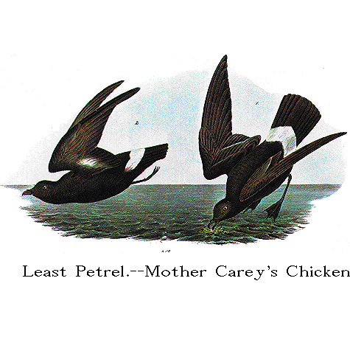

PLUM PICTURES (PRODUCERS)

Plum Pictures was formed in September 2003 by Celine Rattray, Galt Niederhoffer and Daniela Taplin. In a very short time, the company has become one of the most prolific film companies in New York and has had seven films at Sundance.

In 2007, the all-women team had three films in Sundance: GRACE IS GONE, directed by James C. Strouse and starring John Cusack; DEDICATION, directed by Justin Theroux and starring Billy Crudup and Mandy Moore; and GREAT WORLD OF SOUND, directed by Craig Zobel. The Weinstein Company bought GRACE IS GONE and DEDICATION following heated bidding wars, and GRACE IS GONE went on to win the coveted audience award and the Waldo Salt screenwriting award at Sundance as well as the critics award at Deauville. It also was nominated for 2 Golden Globes for best score and best song by Clint Eastwood. GREAT WORLD OF SOUND sold to Magnolia.

Plum’s past credits include THE GROUND TRUTH: AFTER THE KILLING ENDS which premiered at Sundance 2006 and was released by Focus Features; LONESOME JIM directed by Steve Buscemi, starring Casey Affleck and Liv Tyler which premiered at Sundance 2005 and THE BAXTER starring Michael Showalter, Elizabeth Banks, Michelle Williams, and Justin Theroux; both released by IFC Films. WATCHING THE DETECTIVES starring Lucy Liu and Cillian Murphy premiered at Tribeca and will be released in 2008.

Plum has 4 films in post production: BART GOT A ROOM starring William H Macy and Cheryl Hines; DIMINISHED CAPACITY starring Matthew Broderick, Alan Alda, Virginia Madsen; TRUCKER starring Michelle Monaghan and Benjamin Bratt. DIMINISHED CAPACITY and BIRDS OF AMERICA are both in Sundance in January 2008.

Plum is in development on THE RISE OF THEODORE ROOSEVELT which is at Paramount with Leonardo DiCaprio and Martin Scorsese attached to star and direct; the remake of CACHE at Universal, with Ron Howard attached to direct and THE BELL JAR with Julia Stiles starring. Plum will be making the next films by Jim Strouse and Craig Zobel in 2008.

iDEAL PARTNERS FILM FUND (PRODUCERS)

iDeal Partners Film Fund was founded in 2006 by Jana Edelbaum. Adhering to the parameters of Section 181 of the American Jobs Creation Act, iDeal finances and produces independent films made in the United States. iDeal is building a diversified slate of films in partnership with the country’s top film producers. The company’s goal is first and foremost to produce and finance a slate of quality independent feature films and documentaries. At the same time, iDeal manages the downside risk to its partners and collaborators through presales, casting and state tax incentives.

Prior to forming iDeal, Jana Edelbaum spent twelve years as an independent producer. Her credits include ROMANCE & CIGARETTES, released in the fall of 2007, which stars James Gandolfini, Kate Winslet and Susan Sarandon and is written and directed by John Turturro, and ADVICE FROM A CATERPILLAR, which won the Best Feature Award at the US Comedy Art Festival in 2002. Prior to this, she worked in the fixed income and mezzanine finance divisions of Morgan Stanley International UK and the mergers & acquisitions division of Ansbacher Media UK.

iDeal’s Head of Production is Rachel Cohen. Before joining iDeal in 2007, Rachel was EVP at Tribeca Productions, where she developed projects including a biopic about Freddie Mercury and an off-beat comedy called JESUS HENRY CHRIST which she optioned from the All Access Program at the Tribeca Institute. She also did extensive development on THE GOOD SHEPHERD.

Prior to Tribeca, Rachel was SVP Production & Acquisitions at Artisan. Notable acquisitions include THE BLAIR WITCH PROJECT, START UP.COM, and ROGER DODGER. She oversaw a development slate of about a dozen projects, bringing to fruition films like STAGE BEAUTY and DIRTY DANCING 2. Prior to Artisan, she was a Story Editor at Mandalay Entertainment.


HART-LUNSFORD PICTURES, EDWARD J. HART, W. BRUCE LUNSFORD (PRODUCERS)

Hart-Lunsford Pictures is a fully financed, independent film production company based in Louisville, Kentucky. Formed in 2004, Hart-Lunsford Pictures is partnered with Plum Pictures of New York City and has produced seven feature films. The company is financed by Louisville entrepreneurs Ed Hart and Bruce Lunsford, both of whom have extensive backgrounds in the entertainment industry (Mr. Hart in the theme park and outdoor amphitheater business and Mr. Lunsford in thoroughbred racing) and both of whom are among Louisville’s foremost businesspersons.

Of Hart-Lunsford’s seven films, four have been official Sundance Film Festival selections (DEDICATION, DIMINISHED CAPACITY, GRACE IS GONE, and BIRDS OF AMERICA. The Weinstein Company purchased DEDICATION and GRACE IS GONE(the latter having won both the audience award for favorite drama and the Waldo Salt Screenwriting Award at the 2007 Sundance Festival) and recently released them theatrically.

Another of Hart-Lunsford’s films, WATCHING THE DETECTIVES, released by distributor Peace Arch Entertainment, will premiere in theaters on Valentine’s Day 2008.

Hart-Lunsford Pictures does not rely on pre-sales to begin a project and focuses on character-driven projects that have moderate budgets and strong value in all media, while establishing itself as an alternative venue to a traditional Hollywood production company. Although both Hart and Lunsford together decide on greenlighting prospective projects, Lunsford focuses mainly on the business management side, while Hart generally handles the creative direction.

Mr. Hart hails originally from the Bronx, New York. Mr. Lunsford was raised in northern Kentucky near Cincinnati, Ohio.

